**Project 2 Milestone1**

**Description:** For project2, I have two app ideas. The first one is to build an app that helps users customize personal avatar by allowing them choosing and assembling parts including head, body and leg. There will be different layouts for phones and tablets and the avatar should be able to be saved on phone or shared with friends. The second idea is to utilize Google’s Mobile Vision API to create an app to implement functions like face recognition and tracking and then map it with the most related emoji.

**Audience:** These two apps are not limited to a specific group of users but have a broad range of audiences instead. They aim to help people have some fun and boost the use of social media.

**Research:** There are few similar apps in the market and the current apps are kind of dated in both function and design. My apps will have a more robust function, fluent workflow and elegant design.

**Resources:**

Mobile Vision API

**Prototype:**

Random Avatar

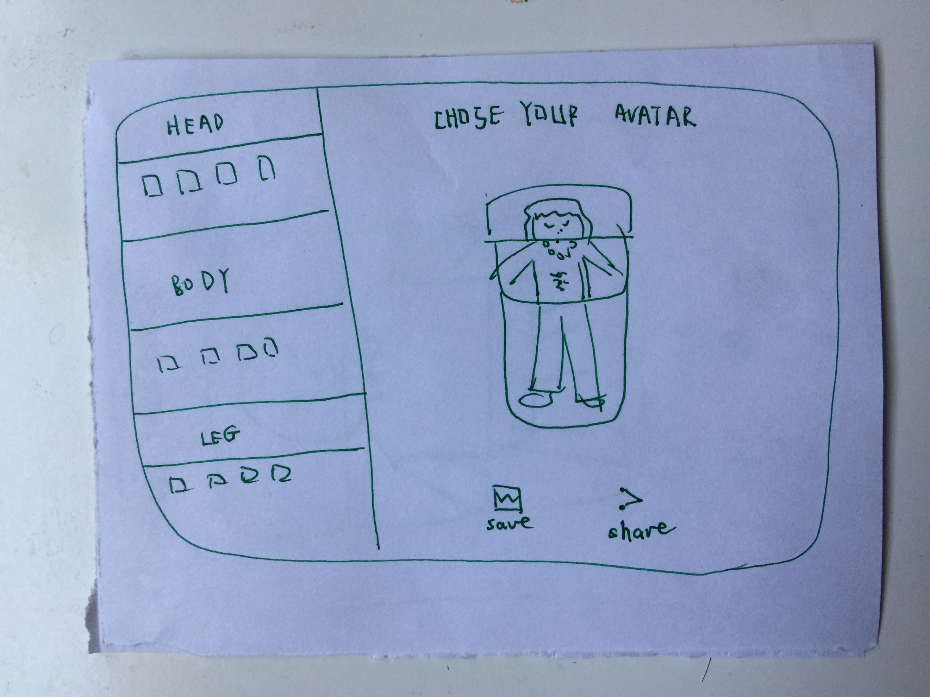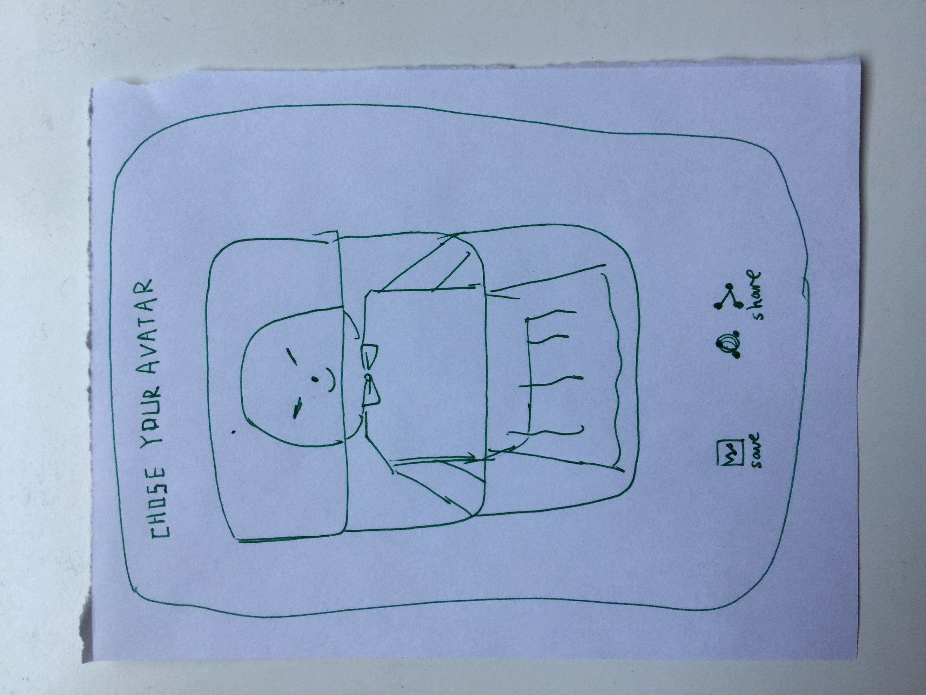

**Phone Tablet**

Emoji Matcher

